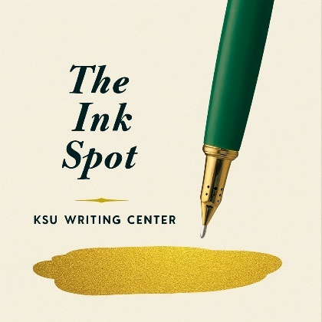
KSU Black History Month Essay Contest
In celebration of the 100th Anniversary of Black History Month, The Ink Spot, KSU’s Writing Center, is announcing its first Black History Month Essay Contest. This centennial anniversary is a significant marker which deserves analysis and documentation. The contest is open to all KSU students enrolled during the Spring 2026 semester.
In 1967, Dr. Martin Luther King, Jr. wrote “Where Do We Go from Here: In Chaos or Community” to analyze the state of the United States a decade after the Civil Rights Movement. 2026’s Black History Month presents opportunities to focus on the current state of Black history after one century of recognition and to document what you see as the future of Black history for next generations. We welcome creative essays that follow the requirements below. We are excited to read what you write!
Essay Prompt:
- “100 Years of Black Legacy: Celebrating Our Past, Mapping Our Future”
  - “Today’s despair is a poor chisel to carve out tomorrow’s justice” – Dr. Martin Luther King, Jr.
  - Research 2-3 events, people, milestones, etc. from Black history. Explain their importance in history and their importance in the current state of Black History in America. Learning from history, discuss how it can help to guide future generations. How will you personally contribute to this progress?
Submission Guidelines:
- Format: MLA-style paragraphs, double-spaced, AND a creative title
- Word Count: Between 1,000 and 1,200 words
- Deadline: Friday, February 13, 2026, at 11:59 p.m.
- Submission: Email your essay to Writing.Center@kysu.edu.
- Include the following contact information at the top left of your essay’s first page:
- Full Name
- Student ID number
- KYSU Email Address
- Submission Date
Prizes & Recognition:
First, second, and third place winners will be selected from the submissions. Each winner will receive a certificate of recognition and an Amazon gift card in honor of their achievement. ($100 for first, $50 for second, and $25 for third.)
If you have any questions, please contact Ollie Rashid (Ollie.Rashid@kysu.edu), Writing Center Coordinator, or Wendell Hixson (Wendell.Hixson@kysu.edu), Writing Center Professional.

